Stevens Institute of Technology
Department of Electrical and Computer Engineering

Spring Semester 2025

CpE 462 Introduction to Image Processing

Homework 1: Due Feb. 6.

1.1 Determine if y[n]=3x[n]+7 is linear? time-invariant?

1.2 Prove that convolution is commutative, i.e. x[n]*h[n]=h[n]*x[n].

1.3.1 Calculate the 1-D convolution x[n]*h[n] using graphic approach, provide necessary intermediate steps.

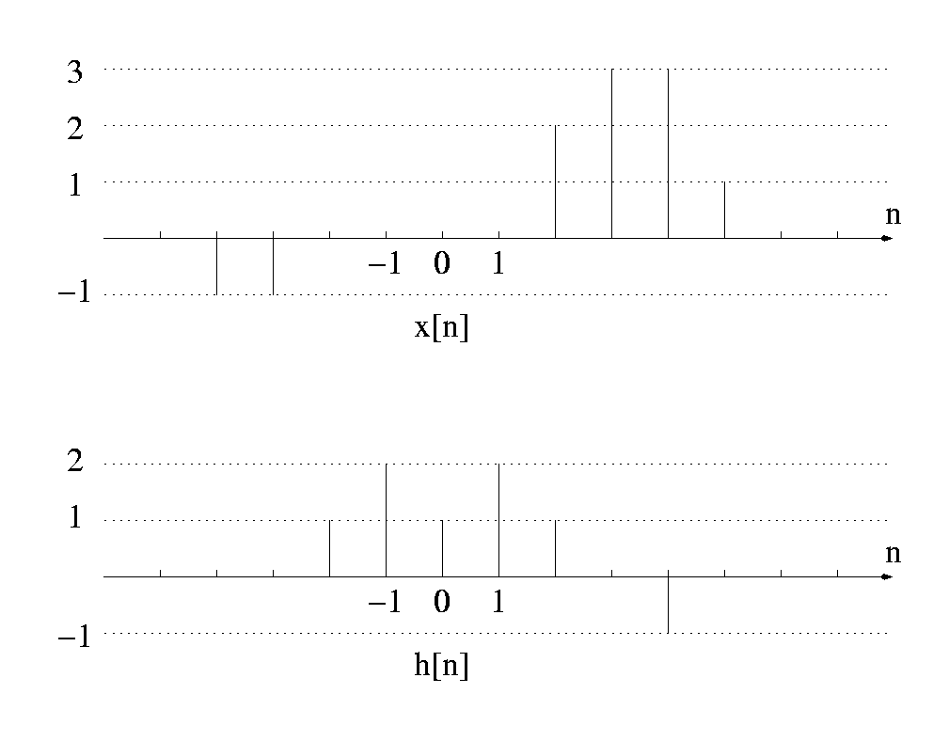
1.3.2 Confirm your results using MATLAB conv function. Show your steps by saving your script using diary command. (Use help to find more about conv and diary in MATLAB.)

